Dear Parents and Families,

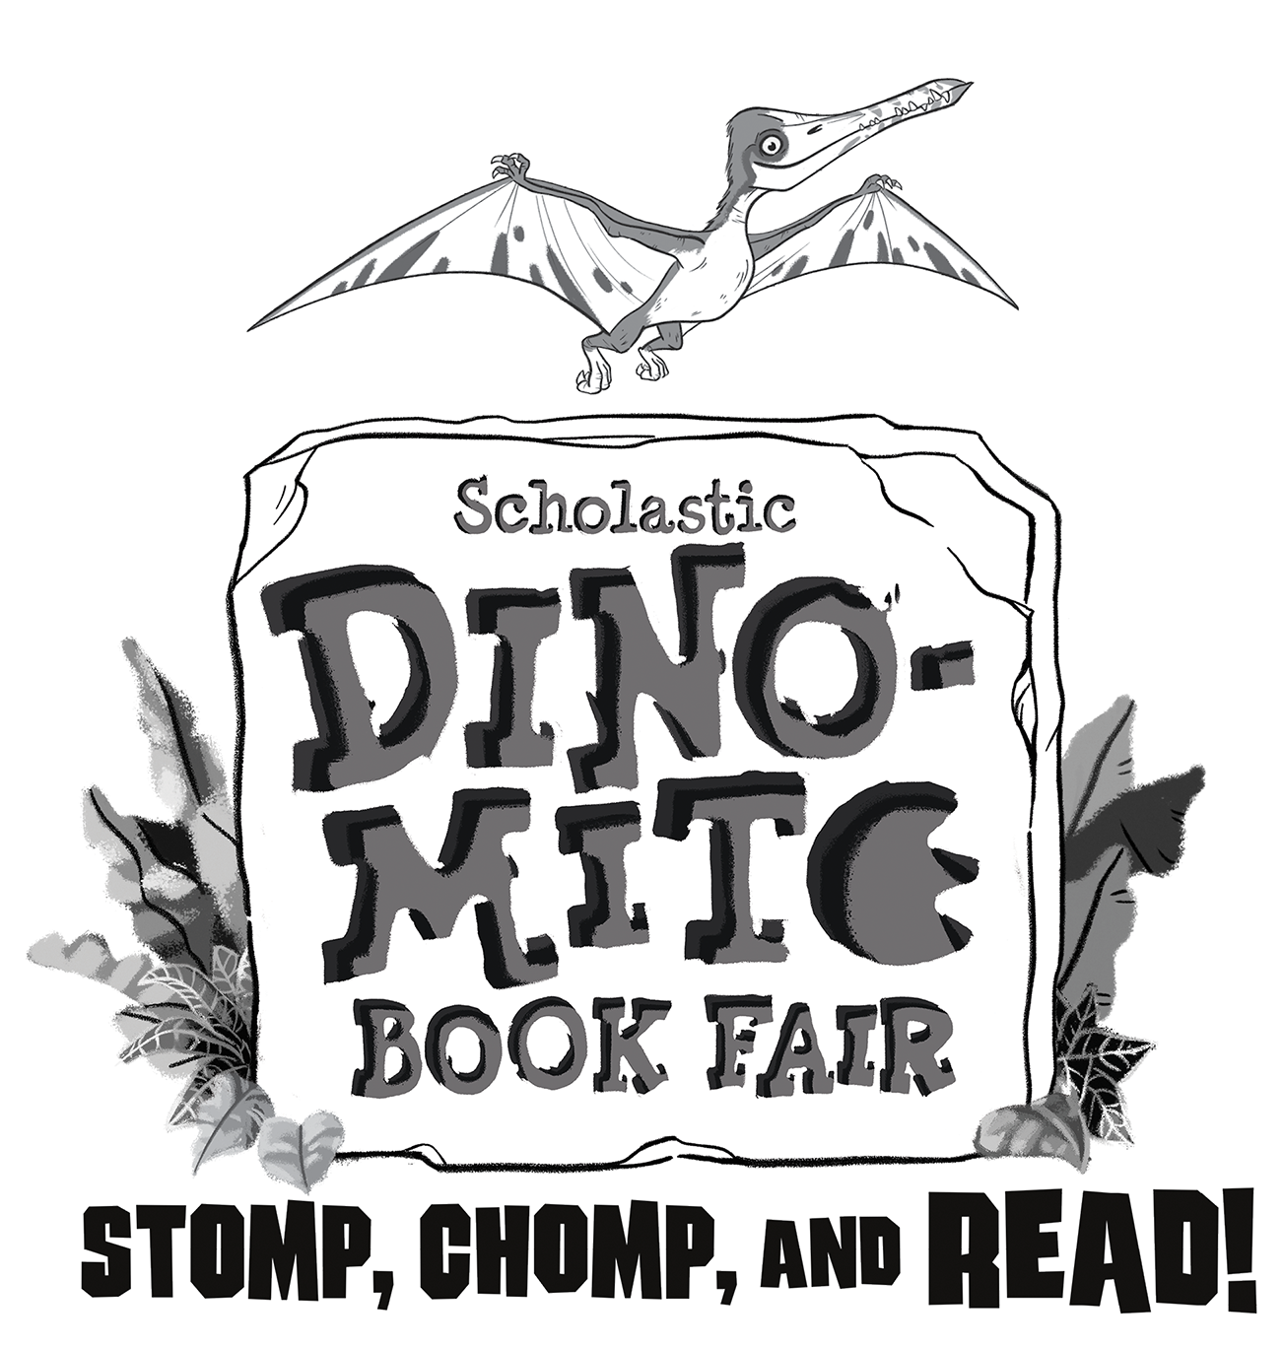
The Scholastic Book Fair is coming to Plainsview!

We invite you to share in this celebration of books and reading with us! Did you know that for every $10 you spend at the book Fair, up to $6 comes directly back to our library? This allows us to purchase needed books and educational resources for our beautiful new space. Our goal is to reach $5000 in sales!

During the week of March 11-15, your child will visit the Book Fair for a preview during class time and will receive a Highlights flyer with a Student Wish List form to select books. For students in Grade 3 to 8, you can simply send the correct amount of money to school with your child and they will be allowed to visit the Book Fair at recess time. For students in Grade K – 2, parents are asked to accompany their child to the Book Fair to purchase books.

On Friday, March 15, the Book Fair will be open for you to visit during Conference Day. Don’t forget to enter our Family Event Draw. You could win $50 in books – $25 for your family and $25 for your child’s classroom!

We hope you will join us at the Book Fair and Thank You for your support of Plainsview School!

Sincerely,

Mrs. Preece

Book Fair Dates: March 11-15

Times:
Monday - Thursday 10:30 - 10:45, 2:15 - 2:30 and 3:37 - 4:00
Conference Day hours: Friday 8:00-5:00

We accept cash, Debit, Visa, MasterCard and American Express. Cheques can be made payable to Plainsview School.

